**A Guide to Google Analytics 4 API with Python**

# Requirement 1: Unlock the GA4 API

Go to [Google Cloud](https://cloud.google.com/) and sign-in using your Google account or Gmail on the upper-right.

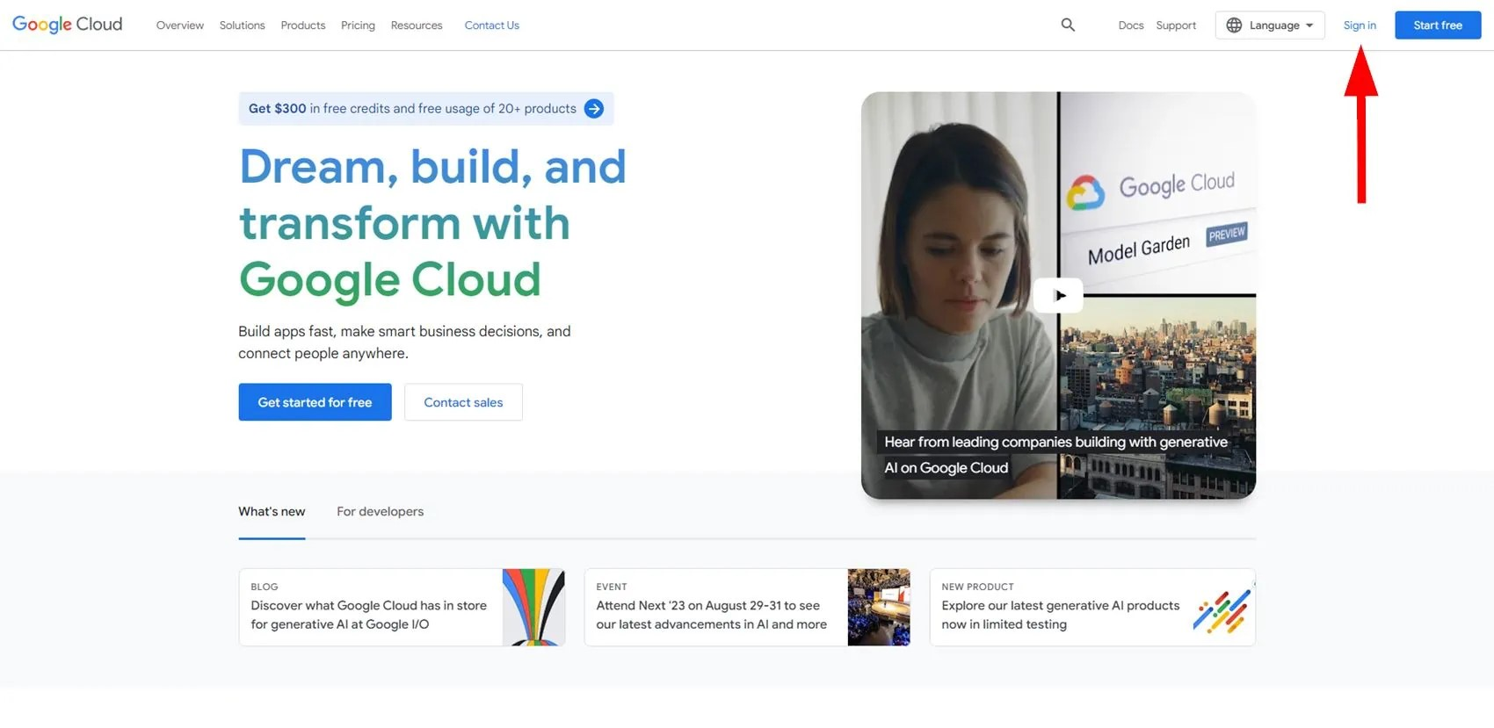

Google Cloud

## Set-Up a Google Cloud Project

First to set-up a Google Cloud Project. After signing-in, create a project.

1: Click on *Select a project* on the upper-left of the page.

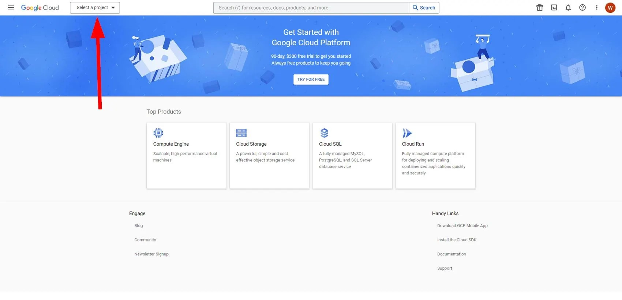

2: Click on *NEW PROJECT*.

3: Give the project a name. In this example, enter ga4-project. As for location, select *No organization* for now. Then click on *CREATE*.

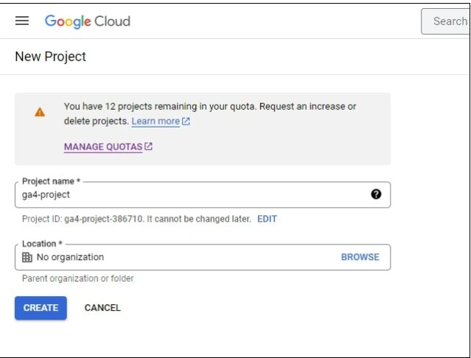

4: Your new project is now created in GCP. Select the project you just created and you’ll be redirected in the workspace of GCP.

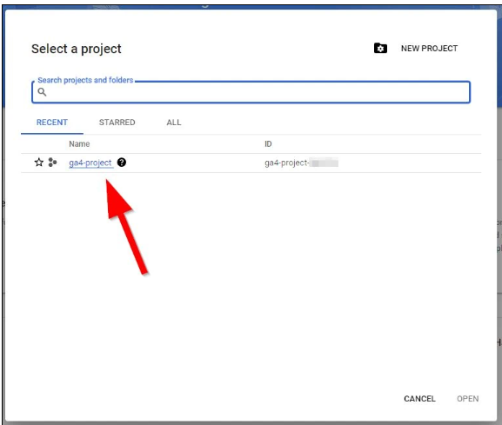

Creating the GCP project is done!

## Add and Enable the API

It’s an additional (and required) step to access the API. You’re going to select and choose which API to use.

1: Inside the workspace, go to the left navigation panel and click on the following:

1 Burger icon (3 horizontal lines) > 2 *APIs & Services* > 3 *Enabled APIs & services*.

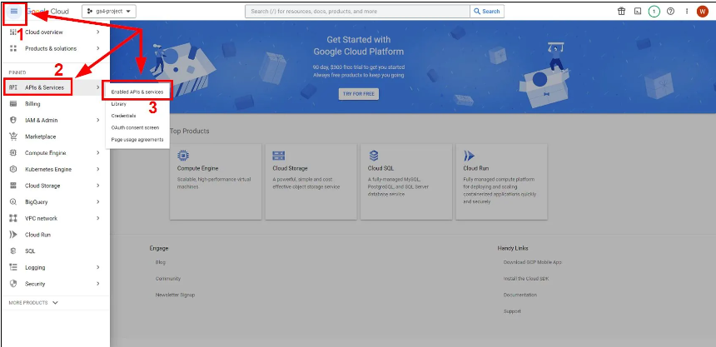

2: Inside *Enabled APIs & services*, click on *+ ENABLE APIS AND SERVICES*. You’ll be redirected to the API Library

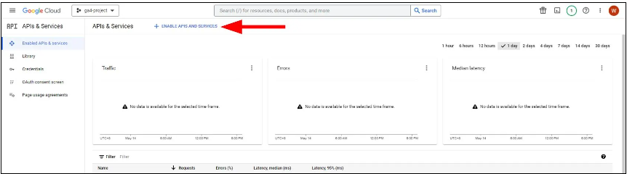

3: Inside product details, click on *ENABLE*. This enables the API or get recognized by GCP.

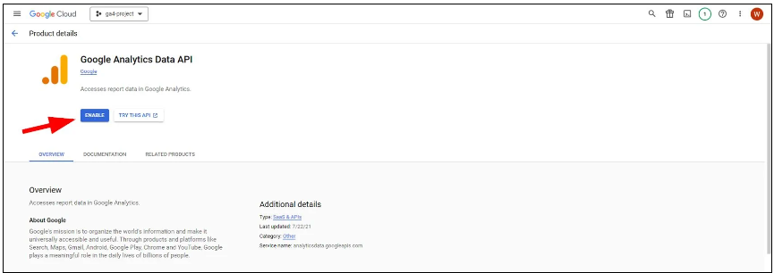

## Create a GCP Service Account

The next thing to do is create a service account. It’s another requirement because an email address is created. This new email is added in the GA4 property with permissions.

1: Inside the workspace, go to the left navigation panel and click on the following:

1 Burger icon (3 horizontal lines) > 2 IAM & Admin > 3 Service Accounts.

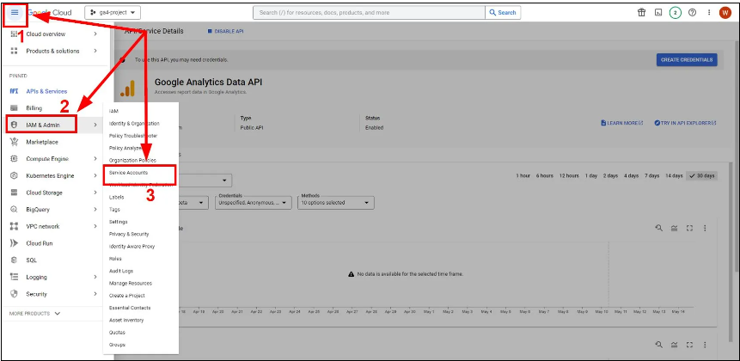

2: Inside *Service Accounts*, click on *+ CREATE SERVICE ACCOUNT*.

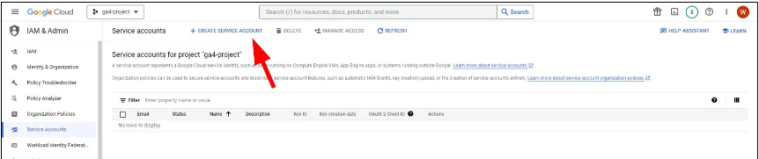

3: Give the service account information. Follow the screenshot below for simplicity.

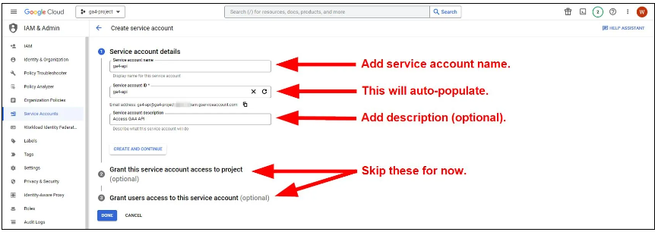

4: Click on *DONE*.

This creates a ga4-api@ga4-project-XXXXXX.iam.gserviceaccount.com email address. **Remember this email address and take note for later.**

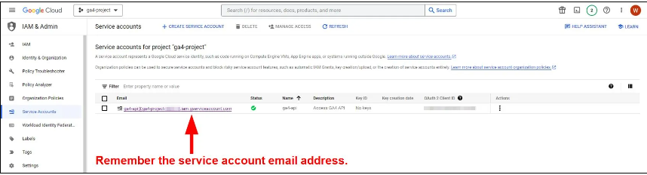

Creating the service account done!

## Download a Private Key JSON File

The next thing is to create and download a JSON le. This JSON le contains the private key and other IDs.

1: Click on the service account email address as illustrated in the screenshot above.

2: Inside *Service account details*, click on *KEYS* in the tabs.

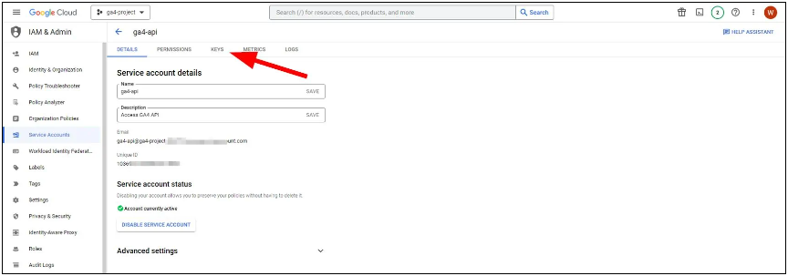

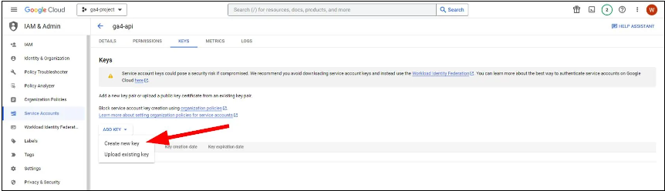

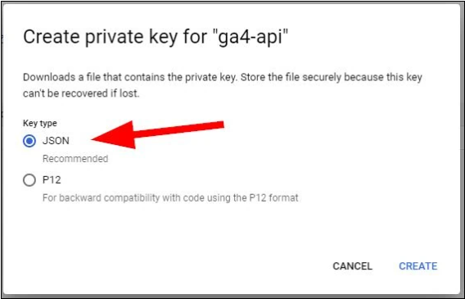

4: In the pop-up window, select JSON. Then click on *CREATE*.

**A JSON le is downloaded on your computer. Remember the le name as well as the le location. These things are important in the coding section later. The le name is something like** ga4-project-XXXXXX-XXXXXXXXXXXX.json

## Grant User Permissions in GA4

The next thing is to grant user permissions for the service account email address in GA4. This allows the email address to view the Google Analytics 4 property of your website.

1: Go back to *Service accounts*. Take note of the service account email address you created earlier. (ex. ga4-api@ga4-project-@gmail.com)

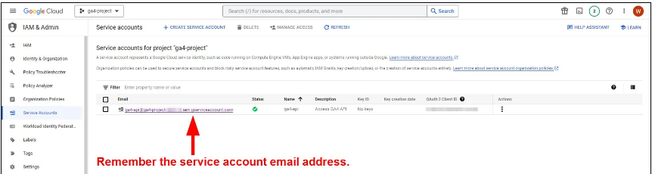

2: Go to your Google Analytics 4 property of your choice. **Note: Decide on your end which GA4 property you want to use.**

3: Under *ADMIN*, click on *Property Access Management or account access management*.

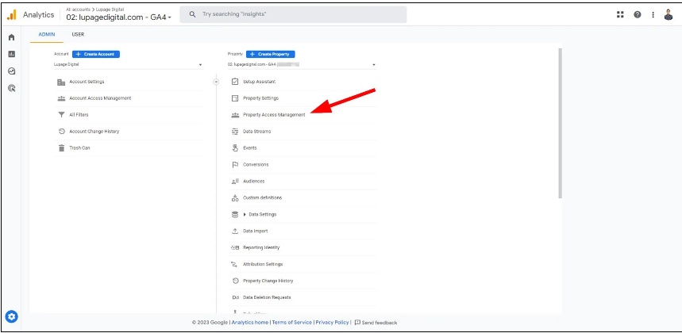

4: Inside *Property Access Management*, Click on + icon then click on *Add users*.

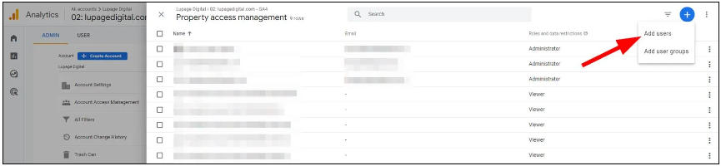

5: Inside *Add roles and data restrictions*, enter the service account email address and then grant Viewer access.

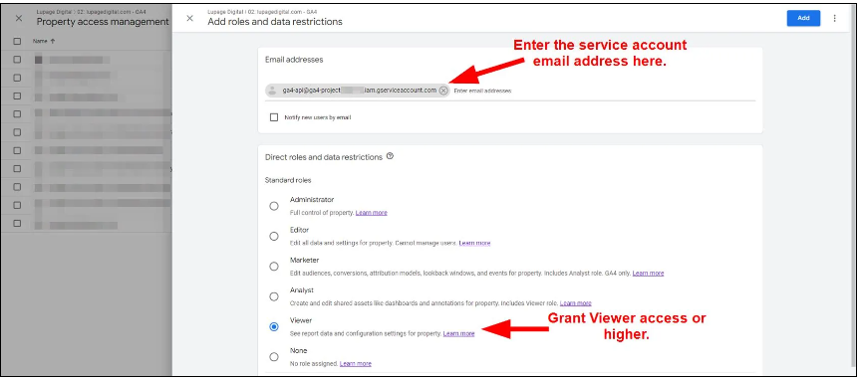

6: Click on *Add* to save it.

**One more thing: you also need to remember the property ID of your Google Analytics 4 property. It’s essential in the coding section later on.**

4: Under *ADMIN*, click on *Property Settings*.

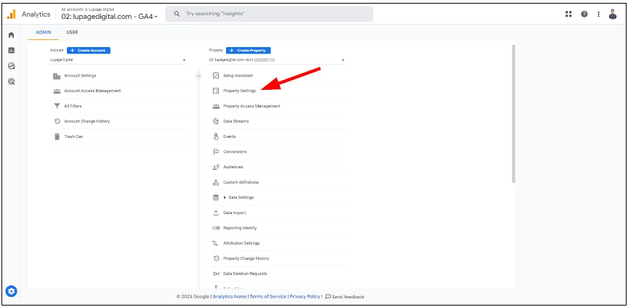

**5: Remember and take note of the property ID from the right side.**

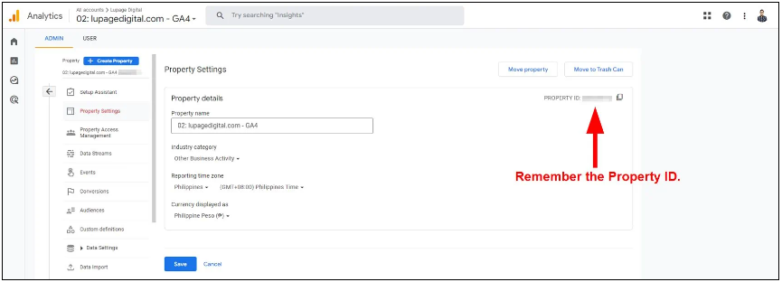

User permission is done!

**Just to recap, you should remember the following for the coding section:**

1. JSON le name
2. GA4 property ID

# Requirement 2: Code in Python

1. Import Necessary modules:

# pip install google-analytics-data

# pip install pandas

# pip install

# pip install google-oauth2-tool

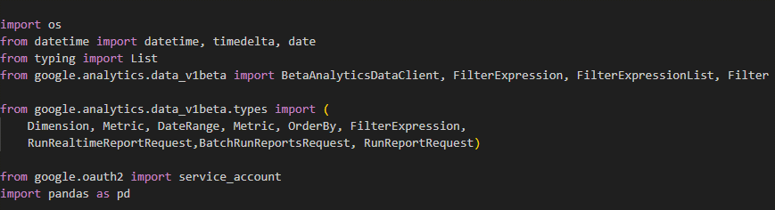

1. Connect with Google Platform using service id or Googles environment.

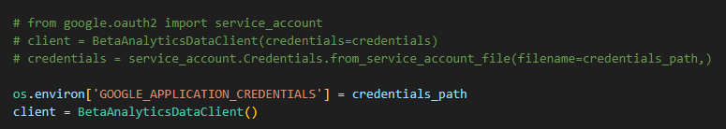

1. set the dimension what you want.

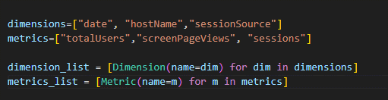

1. This will give the report as response. (Change parameters as per your requirement)

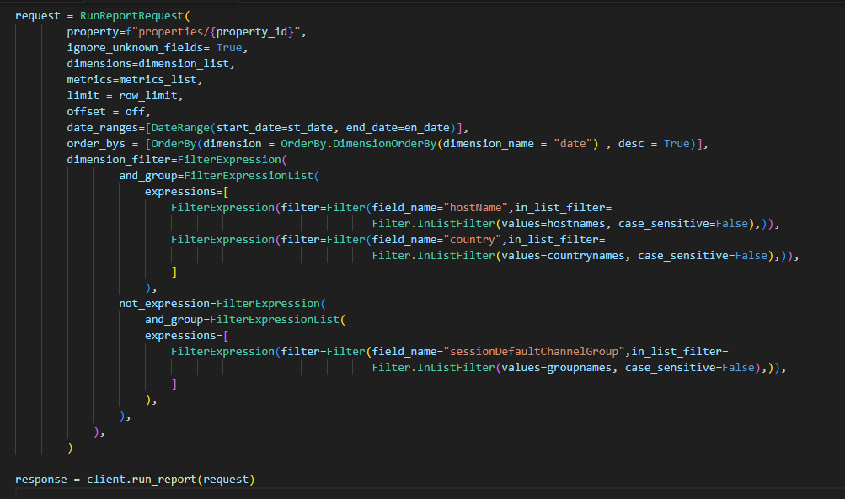

1. The below one will convert the report response to Pandas DataFrame.

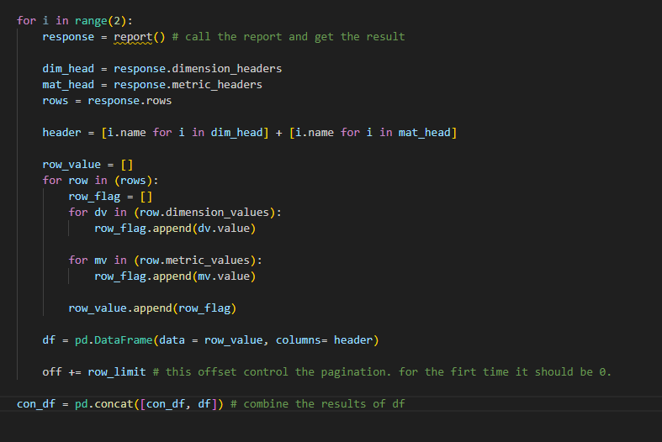

Note:

1. The dimension and metric combination should be valid. Otherwise, it will through an exception.
2. If you need multiple reports at the same time you can use “BatchRunReportRequest”.
3. If you need real-time reports use “RunRealtimeReportRequest”
4. Dimension & Metrics availability check the below link
   1. <https://developers.google.com/analytics/devguides/reporting/data/v1/api-schema#metrics>
5. Make sure that you have enabled GCP Google Analytics Data API and Google Analytic Report API.
6. If you try to fetch more than 250000 rows of data in a single time use pagination. (Use offset)